Brandon Mao

CTC 362

5/8/19

Lab #6 Resubmission

**Requirements Prioritization (Most to Least Important):**

1. Location: Personally, I would want to work somewhere that is near my area. In the long run, this would benefit my financial state by limiting my traveling.
2. Job Growth: While I do measure the location high, this doesn’t mean that I would want to expand my job opportunities and knowledge.
3. Salary: Salary varies depending on the job I am in. Money isn’t everything, but it is always a fundamental aspect to get paid for the work that you have done. Regardless, the amount of earnings I receive remains the balance of this list.
4. Benefits: I don’t mind what benefits a job may offer. The real benefit is getting paid.
5. Job Duties: I don’t really mind what position I may in a job. I will take any duty related to my field.

**Job Listings Based on CISSP Certification Keyword**

1. Emagine IT - Applications Programmer III

* Location: Carson, CA
* Certifications Required: CISSP; CCNA-Security; GSEC; Security + CE; SSCP; CASP CE; CISA; GCED; GCIH

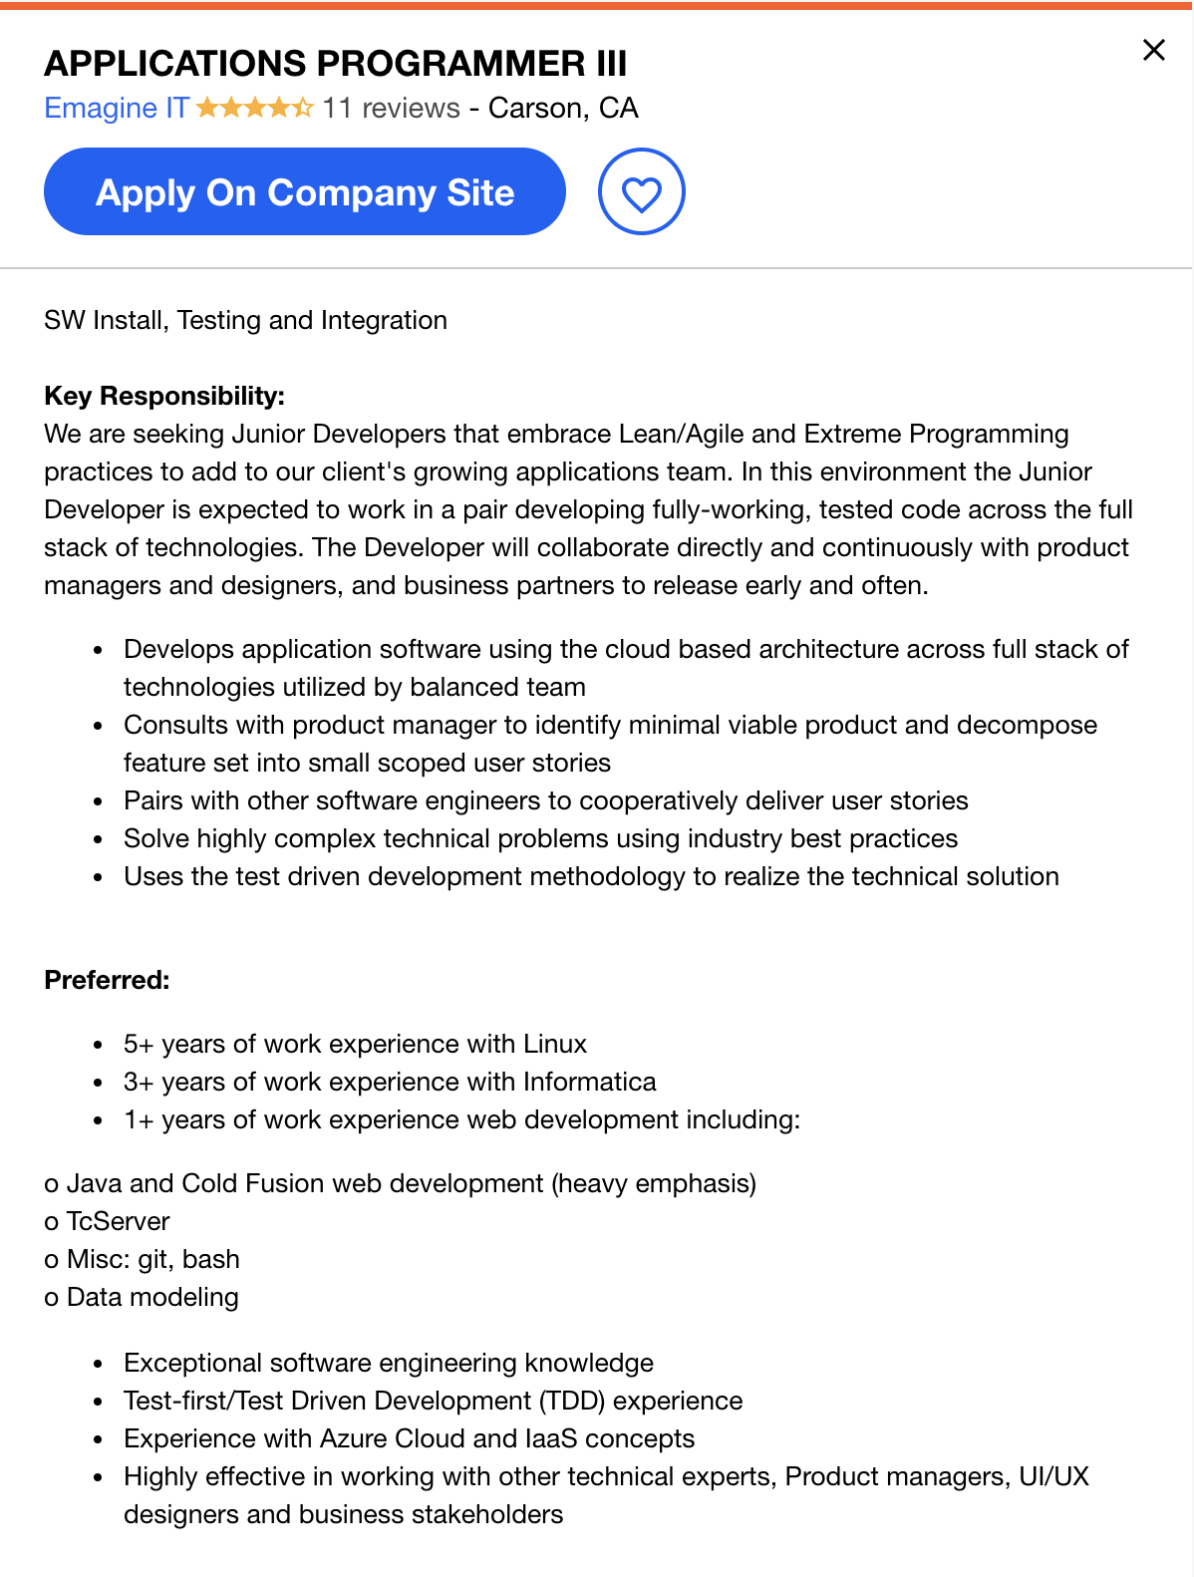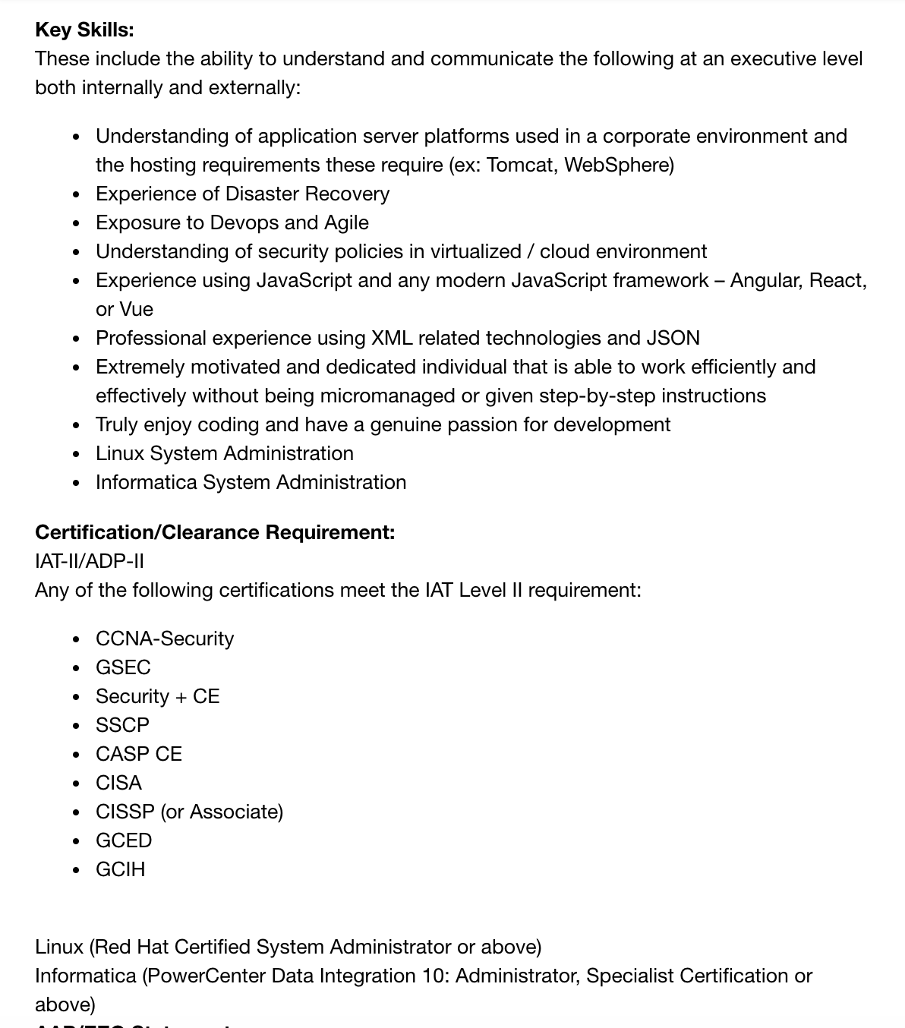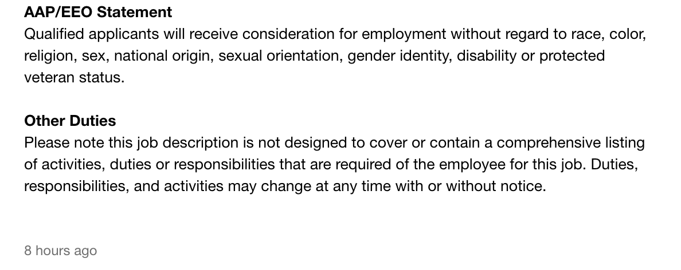

1. Honda R&D Americas, Inc. - Application/Data Protection Architect

* Location: Torrance, CA
* Certifications Required: CISSP; GIAC Security Essentials Certification; GIAC Security Leadership Certification; ISACA Certified Information Security Manager; Microsoft Certified Systems Engineer: Security, (ISC)2 SCCP, CISSP, or ISSAP

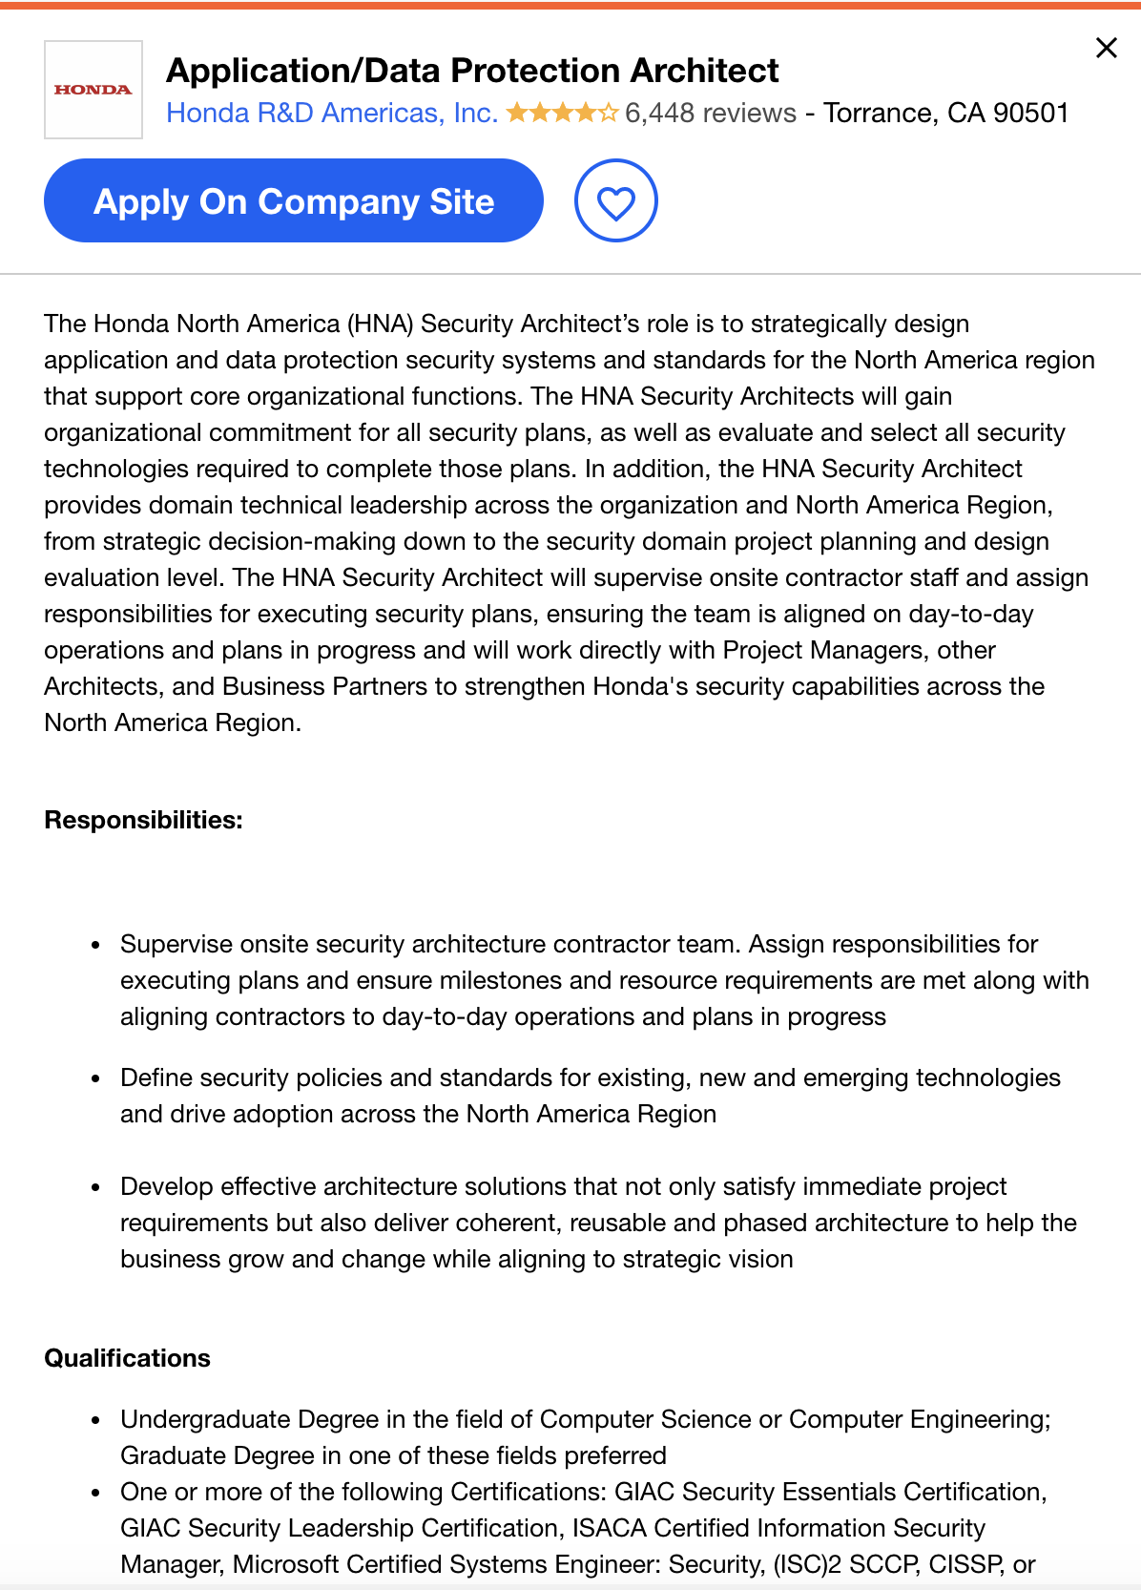

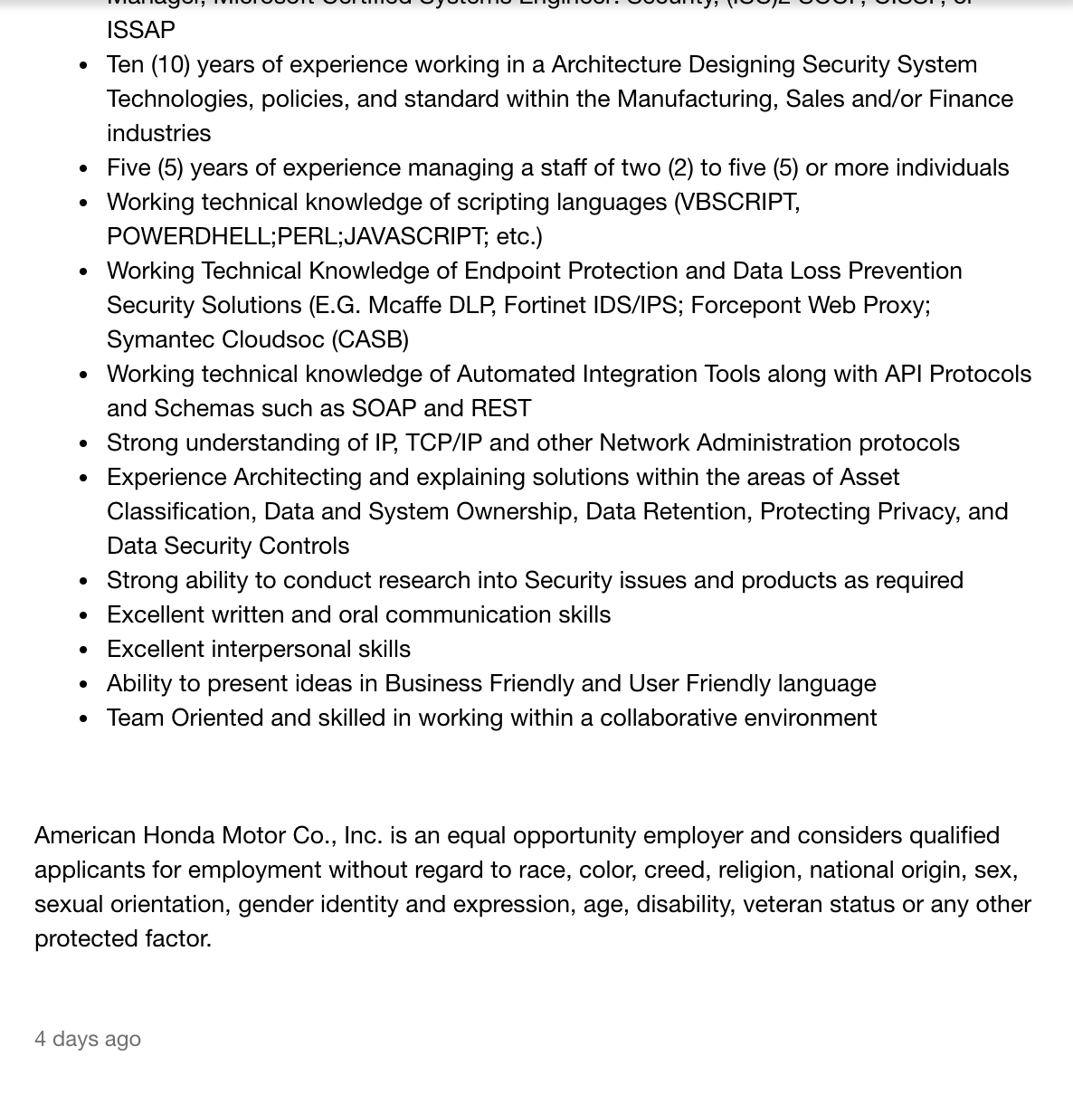

1. Northrop Grumman - Computer Systems Architect 2

* Location: Redondo Beach, CA
* Certifications Required: Information Assurance Credential such as Security+ or CISSP

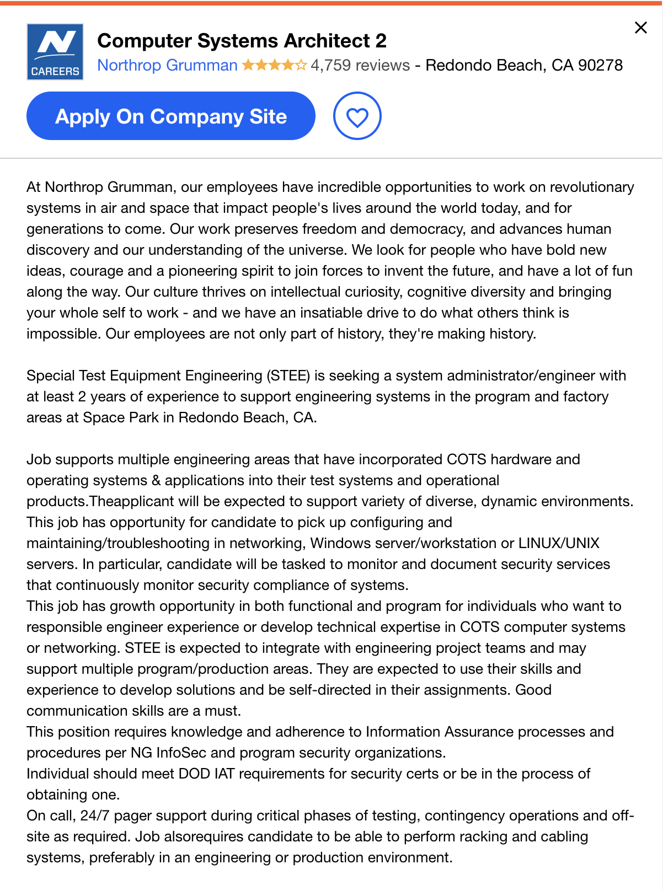

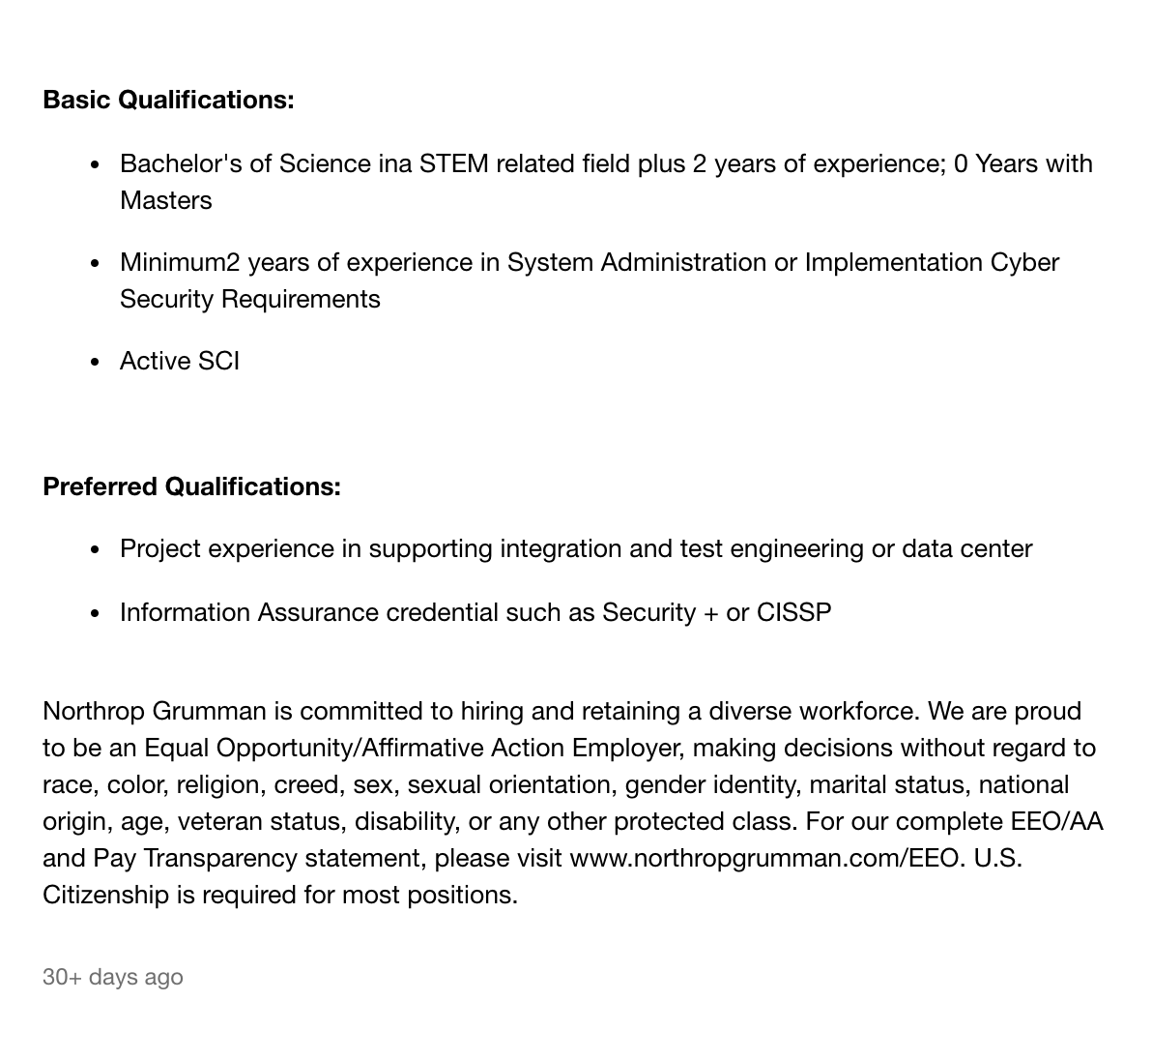

1. Viking Cruises - Information Security Engineer

* Location: Los Angeles, CA
* Certifications Required: IS Certification or Accreditation such as Security, CISSP, or CEH

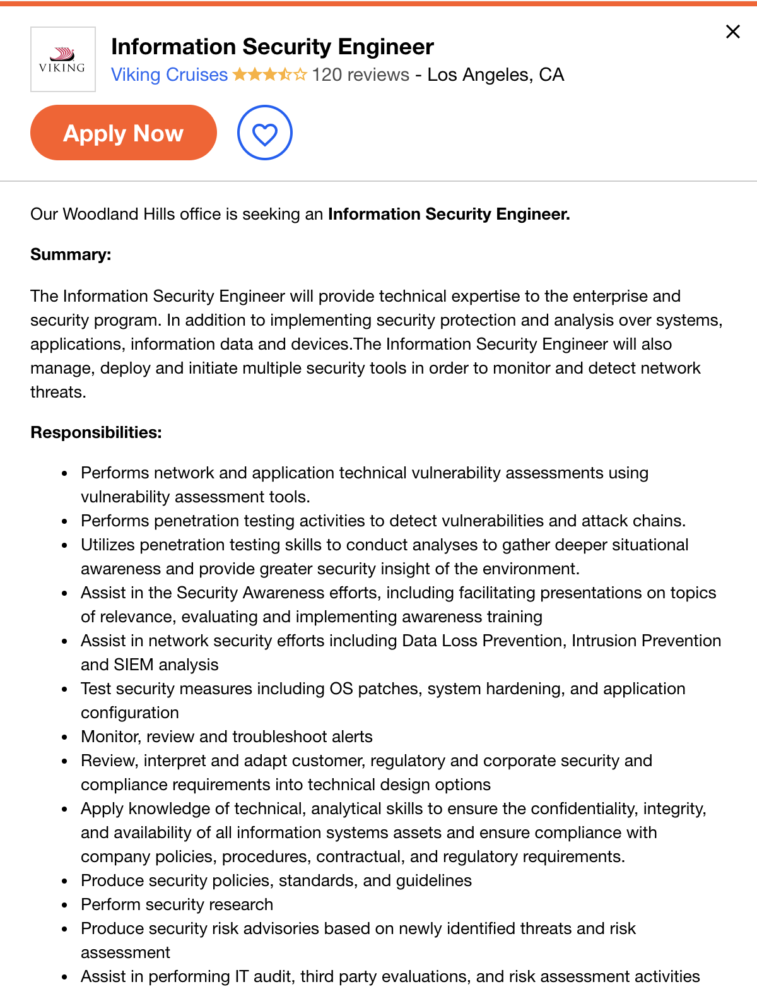

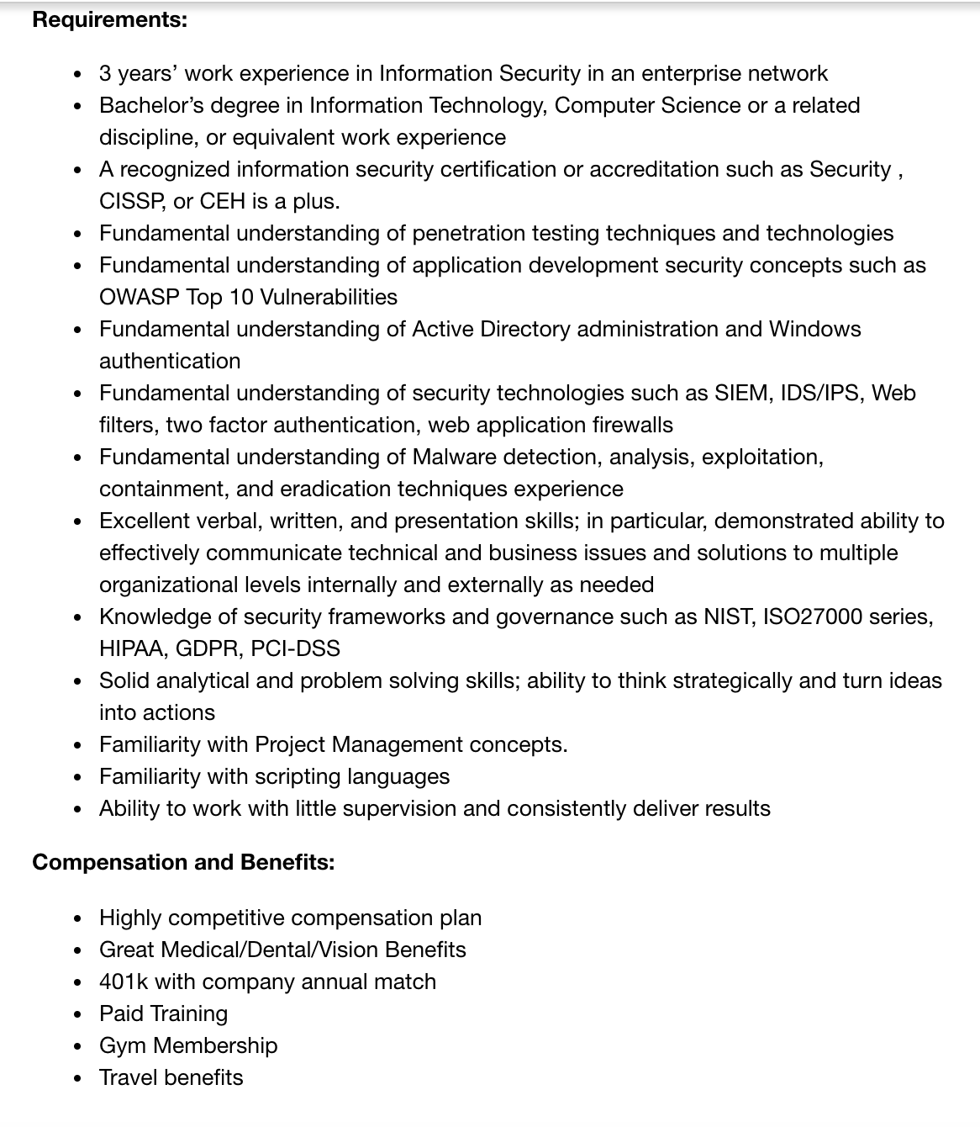

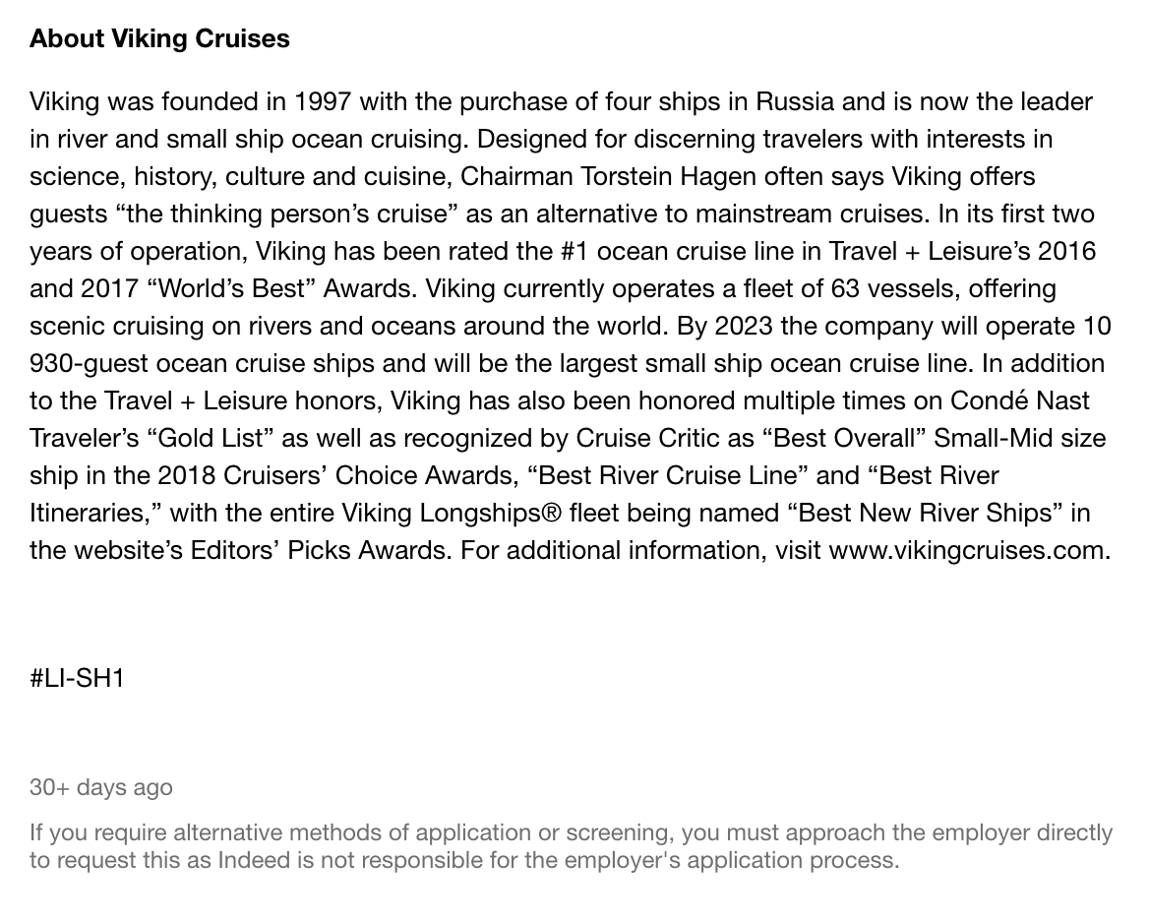

1. Southern California Edison - Cybersecurity Specialist

* Location: Rosemead, CA
* Certifications Required: CISSP; GSEC; GREM; GNFA; CCNA; CISM; GSEC

